

NIT3151 – Predictive Analysis

Stroke Prediction Using Machine Learning Techniques on Healthcare Data

Authors:
Muhammad Taha – s8128767
Justin Dang – s8149950

Student Contribution Table
Student Name, ID | Contribution Section Name
Muhammad Taha s8128767 | Project Summary/Abstract, Introduction, Dataset Description, Detailed predictive Analysis, References
Justin Dang s8149950 | Methods & Algorithm, Results, Conclusion, References

Table of Contents
Student Contribution Table 1
Student Name, ID 2
Contribution Section Name 2
Table of Contents 2
Project Summary/Abstract 3
Introduction 4
Dataset Description 5
Methods and Algorithms 6
Feature Engineering 7
Preprocessing Pipeline 7
Machine Learning Models 7
Evaluation Metrics 7
Detailed Predictive Analysis 8
Results 10
Model Performance Analysis 12
Impact of Class Imbalance 13
Confusion Matrix Insights 13
Conclusion 14
References 16

Project Summary/Abstract
This project focuses on analysing and preparing a healthcare dataset to support the prediction of stroke occurrence using machine learning techniques. Stroke is a major global health issue and early detection is critical for improving patient outcomes. The dataset used in this study contains demographic, medical, and lifestyle information, including factors such as age, hypertension, heart disease, glucose levels, and smoking status.

The initial stages of the predictive analytics lifecycle were carried out, which included data preprocessing and exploratory data analysis. Data cleaning included the management of missing data, the removal of irrelevant data such as unique identifiers, and the management of data inconsistencies in categorical data. Exploratory data analysis was carried out using statistical data and data visualisations to understand the patterns and relationships between the variables and the occurrence of strokes.

During the data analysis, it was evident that the data is highly imbalanced, with fewer instances of strokes compared to non-stroke cases. The major findings included the relationship between strokes and factors such as age, hypertension, heart conditions, and average glucose levels. It is evident that these findings will serve as the basis for the development of predictive models in the future stages of the project.

This project shows the significance of data preprocessing and exploratory data analysis in understanding the data related to the healthcare sector.

Introduction
Stroke is a critical medical condition and is among the top causes of death worldwide. According to the World Health Organisation (WHO), stroke is the second most common cause of death, resulting in about 11% of deaths worldwide. Early detection and prediction of stroke risk are critical in the healthcare sector, which could reduce the complications and improve the outcome of the patient.

With the increased availability of healthcare data, predictive analytics and machine learning techniques could be applied to the data to find patterns and risk factors related to stroke. With the attributes of the patient, such as age, hypertension, heart problems, glucose levels, and lifestyle, data-driven insights could be created to aid the decision-making process in the medical sector.

The aim and objective of this project are to explore and interpret the provided healthcare dataset and understand the significant factors that affect the occurrence of strokes. The early stages of the predictive analysis cycle include data pre-processing and Exploratory Data Analysis (EDA), which are carried out for the provided dataset. The aim is to ensure proper data quality and to find significant patterns in the data, which will eventually help in developing accurate classification models.

Dataset Description
The dataset used in this study is publicly available and comes from Kaggle. It is meant for predicting strokes. The dataset contains patient-level information, with each record representing an individual along with demographic, medical, and lifestyle details. It features various elements related to stroke risk and includes a target variable that shows whether a patient has had a stroke.

The dataset has both numerical and categorical variables. Numerical features include age, average glucose level, and body mass index (BMI), which give measurable insights into a patient’s health. Categorical variables include gender, work type, residence type, smoking status, and marital status, which describe patient traits and lifestyle factors. The dataset also contains binary variables for hypertension and heart disease, indicating whether these medical conditions are present.

The target variable, labelled as stroke, is binary. A value of 1 means the patient has had a stroke, while 0 means they have not. An initial look at the dataset reveals that it is highly imbalanced. There are significantly fewer stroke cases than non-stroke cases. This imbalance is an important aspect of the dataset, as it can influence how well predictive models perform, so it needs to be taken into account in further analysis.

During preprocessing, the dataset was checked for missing values, inconsistencies, and irrelevant features. The id column was recognized as a unique identifier and was removed since it does not help with predictive modelling. The missing values in the BMI feature were replaced with the mean value to ensure the completeness of the data. Furthermore, the “Other” category in the gender feature was discarded as it represented a small proportion of the data.

In conclusion, the dataset is a good set of features required for the prediction of strokes. The features are comprehensive as they cover the required aspects for the prediction, including demographic, clinical, and lifestyle aspects.

Methods and Algorithms

In this stage, machine learning classification models were applied to predict stroke occurrence based on patient health data. The workflow included feature engineering, preprocessing using pipelines, model training, and evaluation.

Feature Engineering
Several medically meaningful features were derived to enhance model performance. Continuous variables such as age, average glucose level, and BMI were grouped into categorical ranges (e.g., age groups, glucose risk levels, and BMI categories). These transformations capture clinically relevant thresholds that may not be easily learned from raw numerical values.
An additional feature, cardio_risk_flag, was created to represent whether a patient has hypertension or heart disease. This feature reflects combined cardiovascular risk and provides stronger predictive signals for stroke occurrence.

Preprocessing Pipeline
A preprocessing pipeline was implemented using a ColumnTransformer to ensure consistent and efficient data preparation. Numerical features were processed using median imputation and standardisation (StandardScaler), while categorical features were processed using most frequent imputation and one-hot encoding.
This pipeline ensures that all preprocessing steps are applied correctly and consistently during both training and testing, while also preventing data leakage.

Machine Learning Models
Five classification models were trained and evaluated:
- Logistic Regression
- Decision Tree
- Random Forest
- Support Vector Machine (SVM)
- K-Nearest Neighbours (KNN)
Hyperparameter tuning was performed using GridSearchCV with stratified cross-validation to optimise model performance.

Evaluation Metrics
Model performance was evaluated using: Accuracy, Precision, Recall, F1 score and ROC-AUC
Special attention was given to recall, as it measures the model’s ability to correctly identify stroke cases, which is critical in healthcare applications where minimizing false negatives is essential.

Detailed Predictive Analysis
Exploratory Data Analysis (EDA) examined the distribution of variables and identified relationships between patient characteristics and stroke occurrence. This step is crucial in predictive analytics because it offers insights into the data structure and helps inform later modelling decisions.
The target variable's distribution showed a significant class imbalance, with many more non-stroke cases than stroke cases. This imbalance is an important observation, as it can lead to biased model performance, where models may favour the majority class. Therefore, it needs careful consideration in the later stages of predictive modelling and evaluation.
Figure 1: Distribution of Stroke Cases
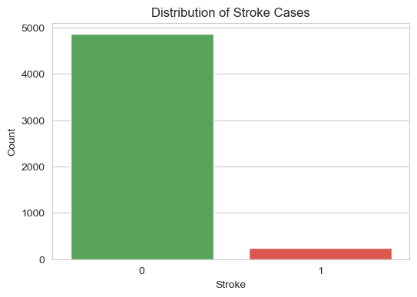
This figure illustrates the significant class imbalance in the dataset, with a much higher number of non-stroke cases compared to stroke cases. This imbalance may impact model performance and must be addressed in later stages.

An analysis of numerical variables provided key insights into stroke risk factors. Age had a strong relationship with stroke occurrence, as stroke cases were generally associated with higher age values. This suggests that older individuals are at a significantly greater risk of having a stroke. Similarly, the average glucose level was higher among stroke patients, indicating a possible link between elevated glucose levels and stroke risk. In contrast, BMI showed less clear separation between stroke and non-stroke cases, suggesting it may have a weaker predictive influence compared to other variables.

Figure 2: Age vs Stroke  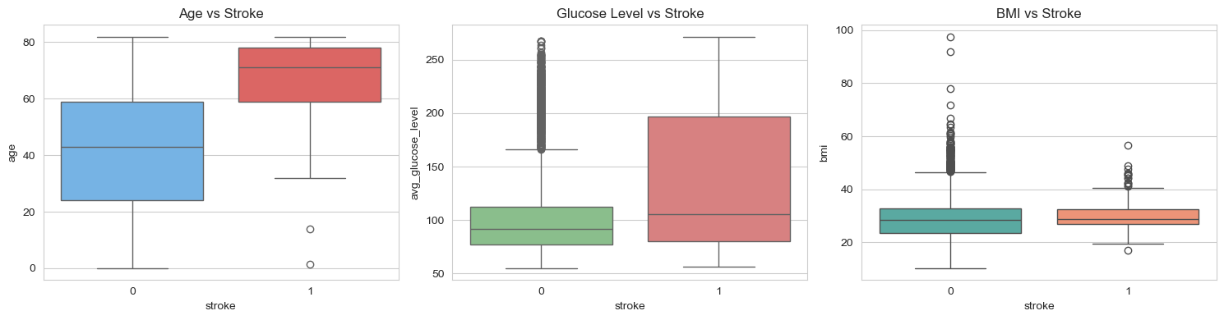  This figure shows that stroke cases are generally associated with higher age values. This indicates that older individuals are at a significantly greater risk of experiencing a stroke. | Figure 3: Glucose Level vs Stroke  This figure indicates that stroke patients tend to have higher average glucose levels compared to non-stroke patients. This suggests a strong association between elevated glucose levels and stroke risk.

Categorical variables were also studied to understand their relationship with stroke occurrence. Patients with hypertension and heart disease had a higher proportion of stroke cases, highlighting these medical conditions as important risk factors. This fits with existing medical knowledge, where cardiovascular conditions are closely linked to stroke. Additionally, variations appeared across smoking status categories, with certain groups showing a slightly higher likelihood of a stroke, although this relationship was not as strong as with clinical factors like hypertension and heart disease.

Figure 4: Heart Disease vs Stroke  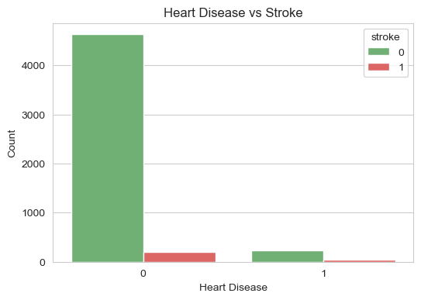This figure shows that individuals with hypertension have a higher proportion of stroke cases compared to those without hypertension. This highlights hypertension as an important risk factor for stroke. | Figure 5: Hypertension vs Stroke  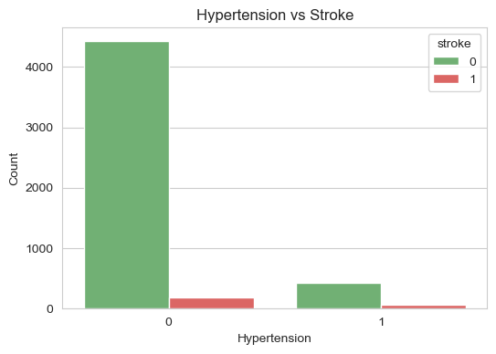This figure shows that individuals with hypertension have a higher proportion of stroke cases compared to those without hypertension. This highlights hypertension as an important risk factor for stroke.

Further analysis using grouped summaries and cross-tabulations supported these findings. For example, the percentage of stroke cases was notably higher among individuals with hypertension and heart disease compared to those without these conditions. These comparisons provide clear evidence of the relationship between underlying health conditions and stroke occurrence.

Correlation analysis of numerical variables examined linear relationships within the dataset. The results showed that age and average glucose level have relatively stronger associations with the stroke variable compared to other numerical features. While correlation does not imply causation, these findings back up the patterns observed in visual analysis.

Figure 6: Correlation Heatmap
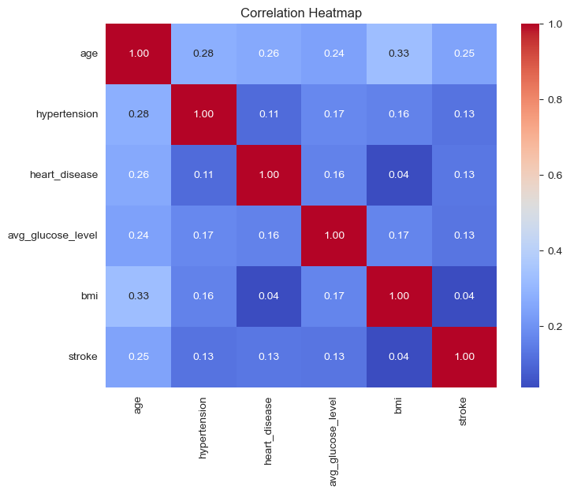
This figure presents the correlation between numerical variables in the dataset. It shows that age and average glucose level have relatively stronger associations with stroke compared to other features.

Overall, the exploratory analysis indicates that age, hypertension, heart disease, and average glucose level are key factors tied to stroke risk in this dataset. These insights are essential for guiding feature selection and improving the effectiveness of predictive models in the project's later stages.

Results (Before and after using SMOTE)

The performance of all models is summarised in Figure 7

Figure 7: Model Performance Comparison Before using SMOTE

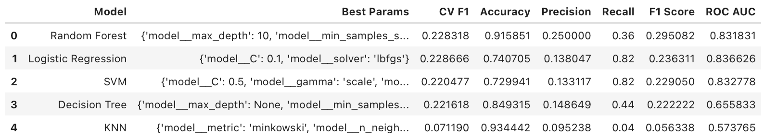
Before applying SMOTE, the models show relatively high accuracy, particularly Random Forest and KNN, which may appear to indicate strong performance. However, the recall values are significantly lower, especially for KNN (0.04) and Random Forest (0.36), indicating that many actual stroke cases are not being detected. This suggests that the models are biased toward the majority class (non-stroke), leading to a high number of false negatives. As a result, despite high accuracy, the models are not reliable for stroke prediction in this imbalanced dataset.

Figure 8: Model Performance Comparison After using SMOTE

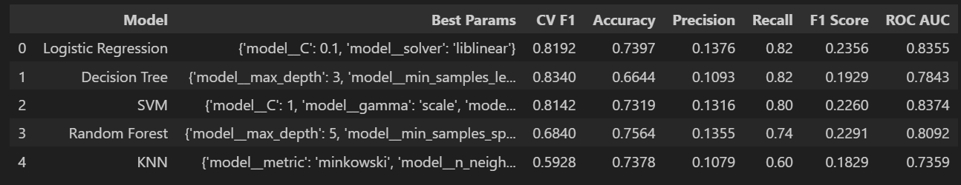After applying SMOTE, there is a clear improvement in recall across all models, with Logistic Regression and Decision Tree achieving the highest recall (0.82), followed by SVM (0.80), Random Forest (0.74), and KNN (0.60). This indicates that the models are now better at detecting stroke cases, with fewer false negatives. Although accuracy and precision decrease due to an increase in false positives, this trade-off is expected and acceptable in healthcare applications. Overall, SMOTE successfully improves model performance by addressing class imbalance and enhancing the detection of the minority class.

Figure 9: Comparison across key evaluation metrics before using SMOTE
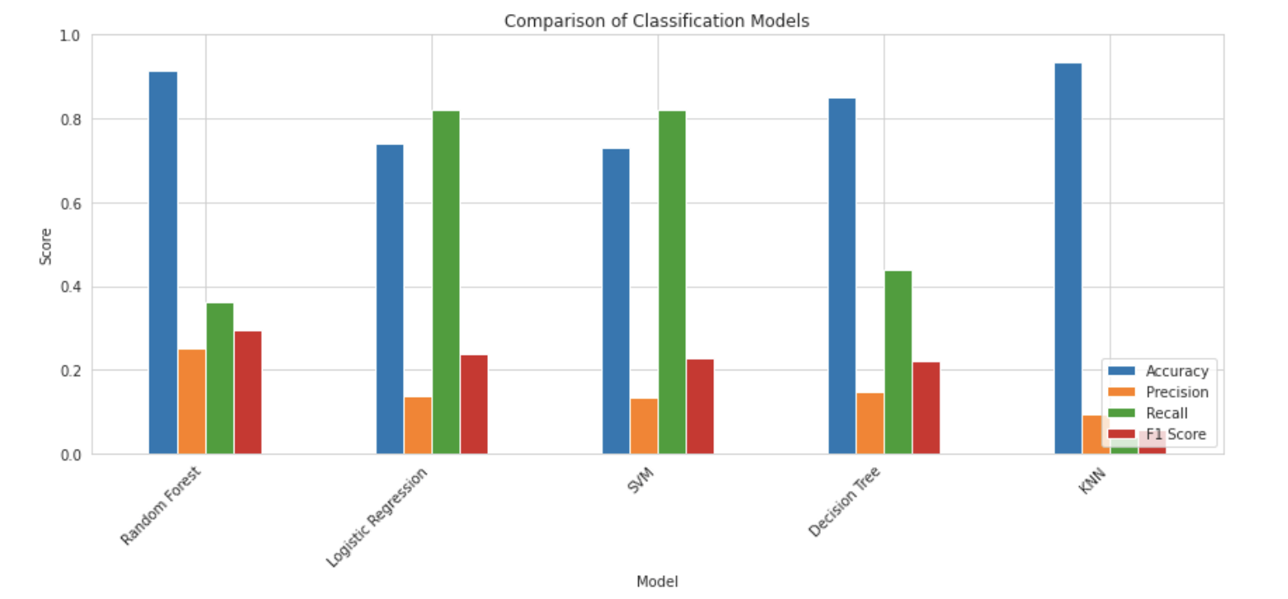
Before applying SMOTE, the bar chart shows that most models achieved high accuracy, particularly Random Forest and KNN, indicating strong performance on the majority class. However, recall values vary significantly and are generally low for some models, especially KNN, which demonstrates extremely poor ability to detect stroke cases. Logistic Regression and SVM achieve higher recall (around 0.82), but this comes with relatively low precision. Overall, the imbalance between high accuracy and low recall suggests that the models are biased toward the majority class and are not reliable for detecting minority class instances such as stroke cases.

Figure 10: Comparison across key evaluation metrics After using SMOTE
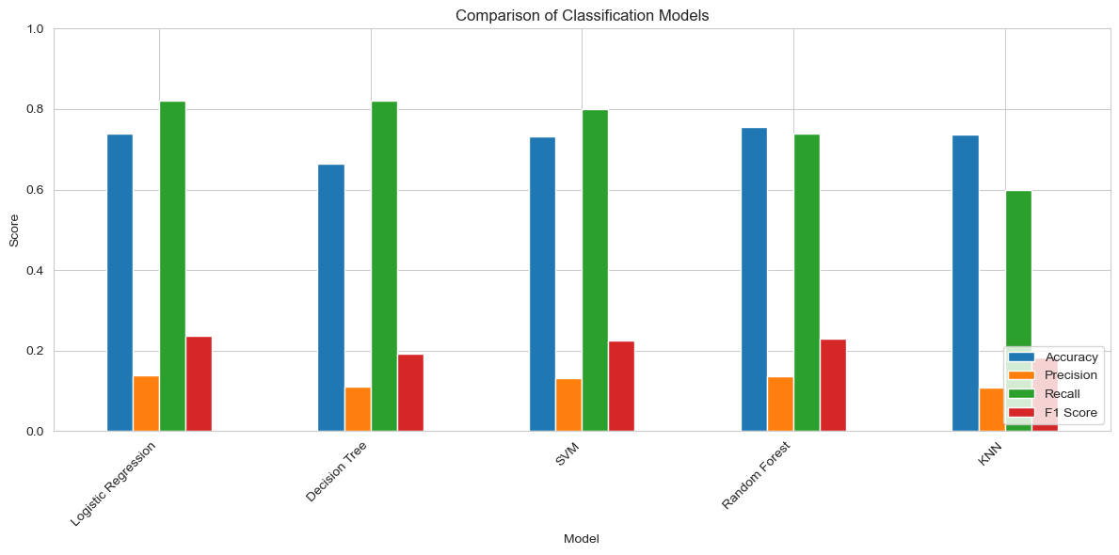After applying SMOTE, the bar chart shows a clear improvement in recall across all models, with Logistic Regression and Decision Tree achieving the highest recall (0.82), followed by SVM, Random Forest, and KNN. This indicates that the models are now more effective at identifying stroke cases. However, accuracy decreases compared to before SMOTE, reflecting an increase in false positives. Precision remains relatively low across models, while F1 scores show moderate improvement. Overall, the results demonstrate that SMOTE successfully improves the balance between classes, making the models more suitable for imbalanced classification tasks where detecting the minority class is critical.

Model Performance Analysis
The results highlight important trade-offs between models:
- Logistic Regression achieved the highest recall (0.82) along with a competitive F1 score, making it the most suitable model for this task. It effectively detects stroke cases while maintaining a reasonable balance between precision and recall.
- Decision Tree also achieved a high recall (0.82), indicating strong ability to identify stroke cases. However, its lower precision and F1-score suggest less balanced performance compared to Logistic Regression.
- SVM demonstrated strong performance with a recall of 0.80 and a comparable F1-score, making it a reliable alternative model, although it still misses slightly more cases than Logistic Regression.
- Random Forest showed moderate performance with a recall of 0.74, indicating improvement compared to before SMOTE, but it still detects fewer stroke cases than the top-performing models.
- KNN improved significantly after SMOTE, increasing recall to 0.60. However, it still underperforms compared to other models, making it less suitable for this task.

Impact of Class Imbalance
The dataset is highly imbalanced, which initially caused models to favour the majority class and perform poorly in detecting stroke cases. After applying SMOTE, the class distribution becomes more balanced, allowing models to better learn patterns of the minority class.
As a result, recall improves significantly across all models, indicating better detection of stroke cases. However, this comes with a decrease in accuracy and precision due to an increase in false positives.
Therefore, recall remains the most important metric in this study, as minimizing false negatives is critical in healthcare applications. F1-score is used as a supporting metric to evaluate the balance between precision and recall, while accuracy is less reliable due to the nature of imbalanced data.

Confusion Matrix Insights
The confusion matrix analysis shows that Logistic Regression and Decision Tree achieved the highest number of true positives (41) and the lowest number of false negatives (9), indicating the strongest ability to detect stroke cases. SVM performed slightly lower with 40 true positives and 10 false negatives, while Random Forest and KNN showed reduced performance, missing 13 and 20 stroke cases respectively. Since minimizing false negatives is critical in healthcare applications, Logistic Regression is the most suitable model as it detects the most stroke cases while missing the fewest.

Figure 11: Confusion matrix of the Logistic Regression model.

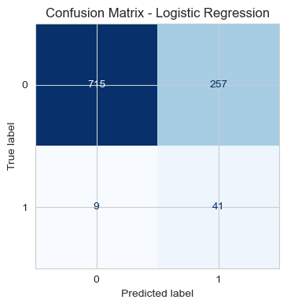

The Logistic Regression model correctly identified 41 stroke cases (TP) and missed only 9 cases (FN). This indicates a strong ability to detect positive cases, resulting in high recall. The relatively low number of false negatives is critical in a healthcare context, as it means fewer at-risk patients are overlooked. Overall, this model demonstrates the best performance in identifying stroke cases.

Figure 12: Confusion matrix of the Decision Tree model.
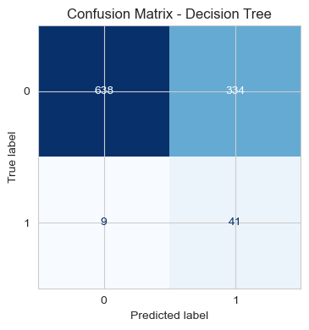

The Decision Tree model correctly detected 41 stroke cases (TP) and missed 9 cases (FN), achieving the same recall as Logistic Regression. However, despite having equal detection capability, it produces more false positives, indicating lower precision. While it is effective at identifying stroke cases, it is less efficient due to generating more unnecessary alerts.

Figure 13: Confusion matrix of the SVM model.
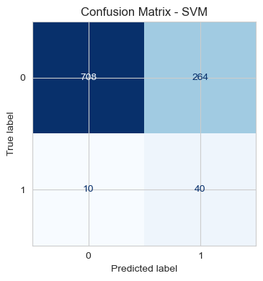
The SVM model correctly detected 40 stroke cases (TP) and missed 10 cases (FN), showing strong performance in identifying positive cases. Its recall is slightly lower than Logistic Regression but still relatively high. This indicates that SVM is a reliable model for stroke detection, although it still misses more cases than the best-performing model.

Figure 14: Confusion matrix of the Random Forest model.
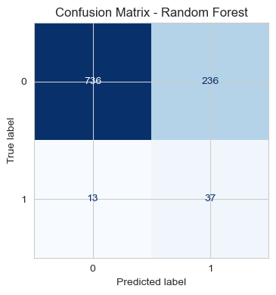
The Random Forest model correctly identified 37 stroke cases (TP) but missed 13 cases (FN). Compared to Logistic Regression, it fails to detect more actual stroke cases, resulting in lower recall. This suggests that the model is less effective in identifying high-risk patients, which is a limitation in healthcare applications where minimizing missed cases is crucial.

Figure 15: Confusion matrix of the KNN model.
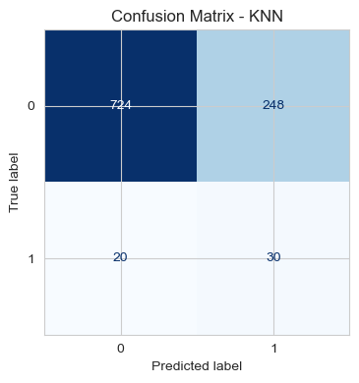

The KNN model correctly identified only 30 stroke cases (TP) and missed 20 cases (FN), resulting in the lowest recall among all models. This indicates poor performance in detecting stroke cases, as a significant number of positive instances are not identified. Therefore, KNN is not suitable for this task where minimizing false negatives is critical.

Conclusion

This project demonstrated the application of machine learning techniques to predict stroke occurrence using healthcare data. The results highlight the importance of effective feature engineering and preprocessing in improving model performance and extracting meaningful patterns from the dataset.
A key finding of this study is the significant impact of class imbalance on model performance. Before applying SMOTE, several models achieved high accuracy but performed poorly in detecting stroke cases, indicating a strong bias toward the majority class. After applying SMOTE, the class distribution became more balanced, leading to a substantial improvement in recall across all models and enabling better identification of stroke cases.
Among the models evaluated, Logistic Regression emerged as the most suitable model for this task, as it achieved the highest recall (0.82) while maintaining a reasonable balance with other evaluation metrics. This indicates that it is the most effective in identifying stroke cases and minimizing false negatives, which is critical in healthcare applications. Decision Tree achieved similar recall but produced more false positives, while SVM also demonstrated strong performance but slightly lower recall. Random Forest and KNN showed lower effectiveness in detecting stroke cases compared to the top-performing models.
The study also highlights the trade-off between recall and precision. While recall improved after applying SMOTE, precision and accuracy decreased due to an increase in false positives. However, this trade-off is acceptable in healthcare scenarios where missing a stroke case is more critical than generating false alarms. Therefore, recall was prioritised as the most important evaluation metric, with F1-score used as a supporting measure.
Overall, this study demonstrates that machine learning can effectively support early stroke risk prediction when appropriate techniques, such as handling class imbalance, are applied. Future work could explore advanced techniques such as threshold tuning, cost-sensitive learning, or ensemble methods to further improve model performance and reduce false positives.

Figure 16: Recommend model based on Recall
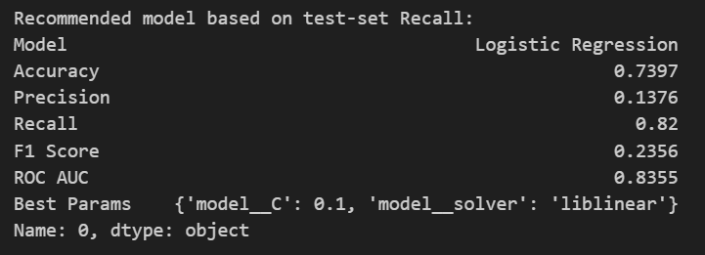

References
- Harrington, P. (2012). Machine learning basics. In Machine learning in action. Manning Publications. Retrieved from https://learning.oreilly.com
- Harrington, P. (2012). Classifying with k-nearest neighbors. In Machine learning in action. Manning Publications. Retrieved from https://learning.oreilly.com
- Harrington, P. (2012). Decision trees. In Machine learning in action. Manning Publications. Retrieved from https://learning.oreilly.com
- Harrington, P. (2012). Support vector machines. In Machine learning in action. Manning Publications. Retrieved from https://learning.oreilly.com
- Zhou, Z.-H. (2021). Linear models. In Machine learning (pp. 57–77). Springer. https://doi.org/10.1007/978-981-15-1967-3_3
- Kaggle. (n.d.). Stroke prediction dataset. Retrieved from https://www.kaggle.com/datasets/fedesoriano/stroke-prediction-dataset
- World Health Organization (WHO). (2023). Stroke statistics and global health estimates. Retrieved from https://www.who.int
- Victoria University. (2026). NIT3151 Predictive Analytics unit materials. VU Collaborate. https://vucollaborate.vu.edu.au/d2l/home/2362259

